


Zebex 3220+
[Configuration Sheet]
Barcode | Function
 | Enter Configuration Mode
 | Restore Default Factory Settings
 | Exit Configuration Mode
 | Enter Configuration Mode
 | Restore USB Defaults
 | Exit Configuration Mode
 | Enter Configuration Mode
 | International Keyboard Mode
 | Add Prefix
 | Add Tilde
 | Validate Prefix
 | Set Prefix
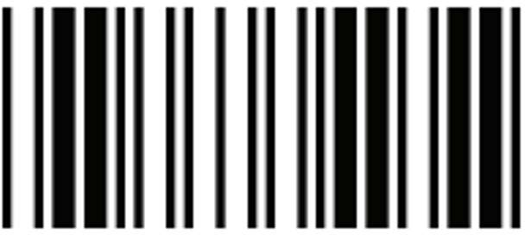 | Exit Configuration Mode

