


Zebex 3250
[Configuration Sheet]
Barcode | Function
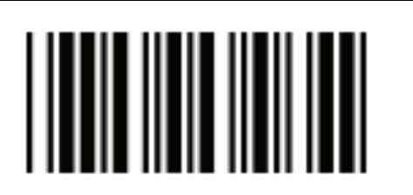 | Enter Configuration Mode
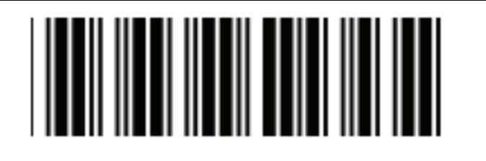 | Factory Defaults
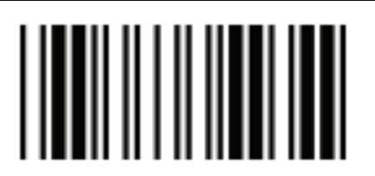 | Exit Configuration Mode
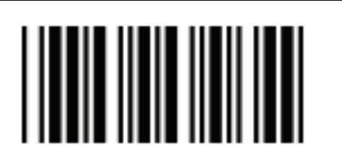 | Start of Configuration
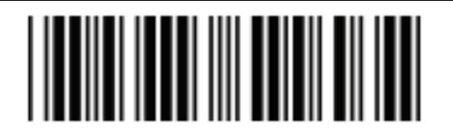 | HID mode
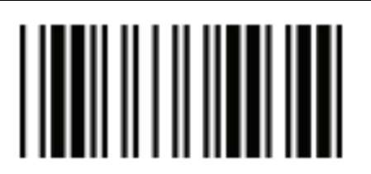 | Exit Configuration Mode
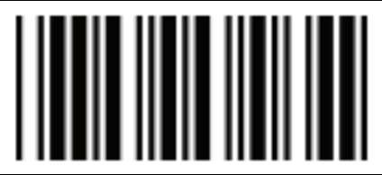 | Start of Configuration
 | Set Keyboard Language to UK
 | Preamble
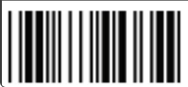 | Tilde ~
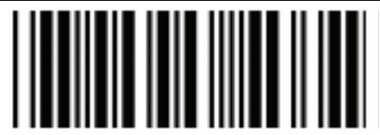 | Confirm / SET
 | Exit Configuration Mode

